Ex.No.4: OFDMA Resource Block Allocation Date

AIM: To simulate and analyze OFDMA (Orthogonal Frequency Division Multiple Access) resource block allocation and evaluate system performance in terms of resource utilization and user throughput using MATLAB.

Objective
- To determine the Number of Resource Blocks (RBs) allocated in an OFDMA system based on available bandwidth and system configuration.
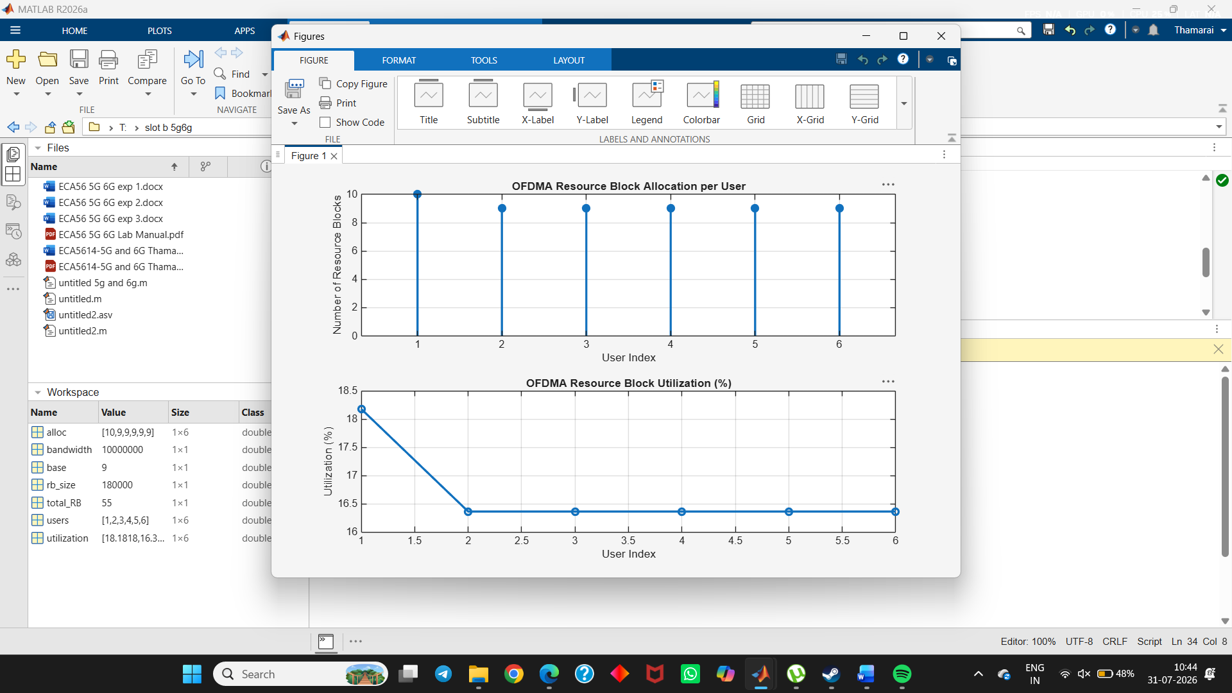
2.
To evaluate the Resource Block Utilization (%) by analyzing how efficiently available RBs are assigned to active users.
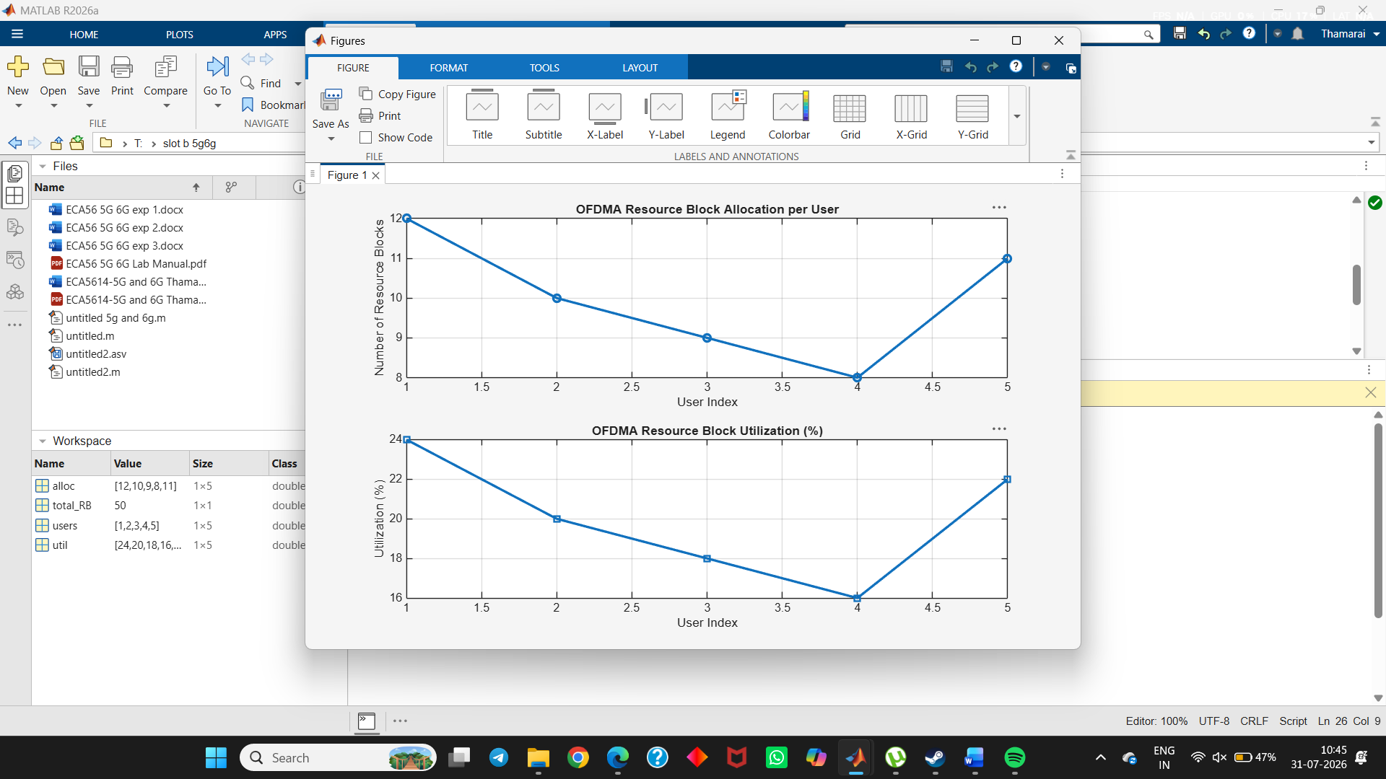
3.
To calculate the User Throughput (Mbps) based on allocated resource blocks and modulation efficiency in the OFDMA system.
